I have logged in as an “Audit User”. Entered “Third Party details” and clicked SAVE.

I get the following error

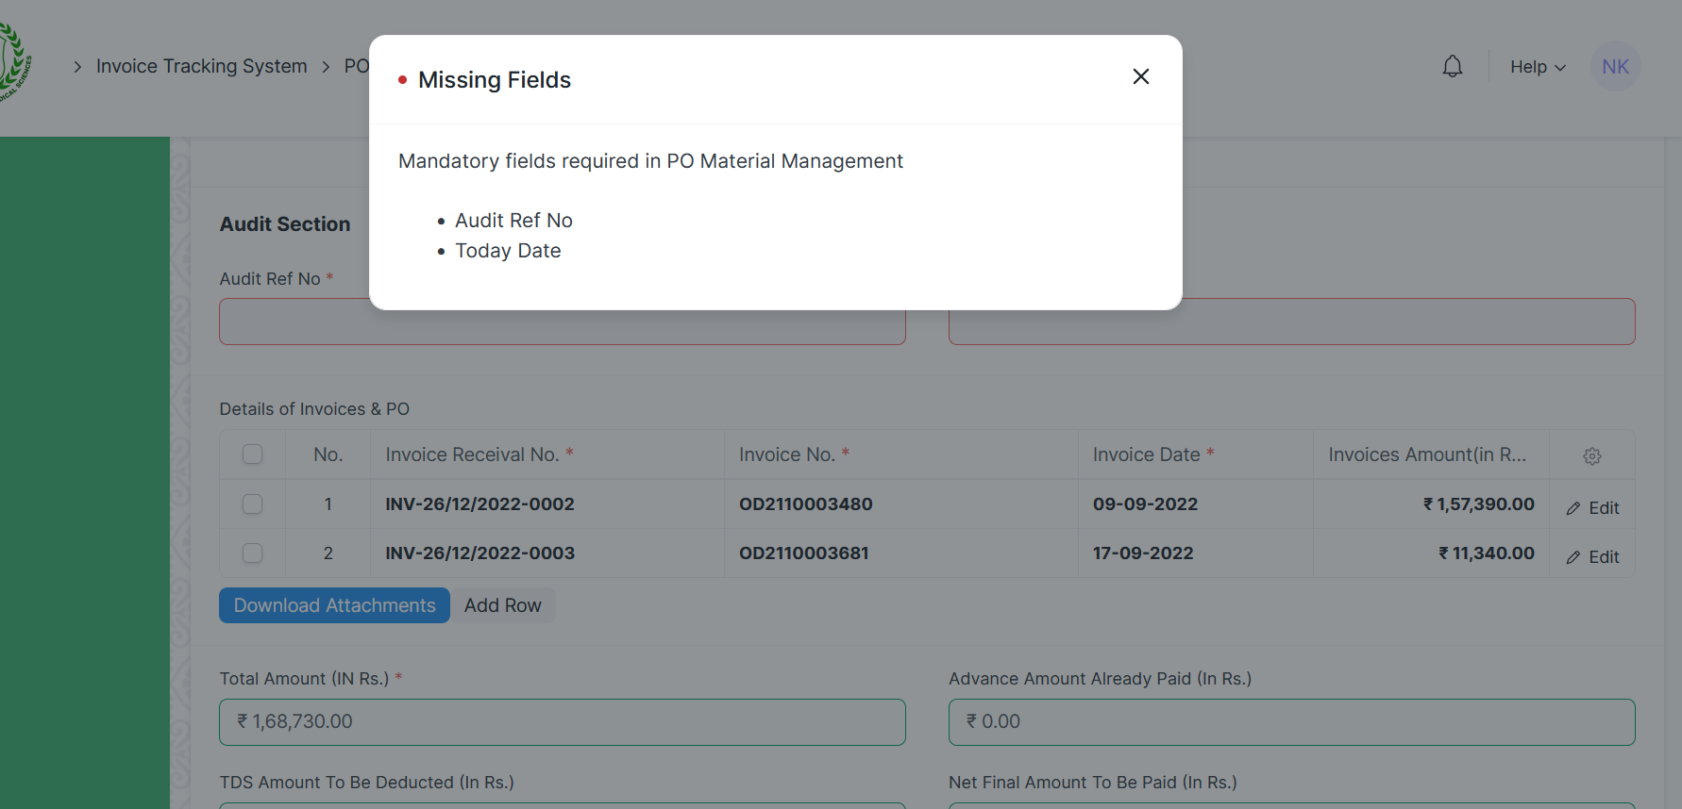

I try to enter Audit Ref No field value, system doesn not allow to enter. Also, Save / Actions button disappears.

